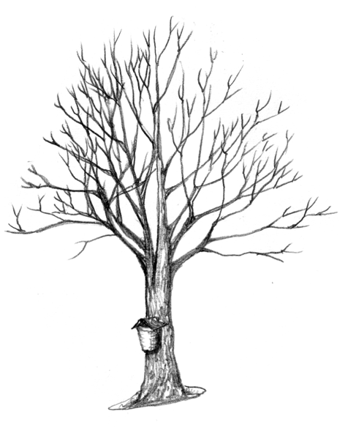
Think Maple!

As Natural Resource Service Providers or as woodland owners we start with a vision. That can be a vision of what we want to forest to provide, in terms of goods and services. It can be a vision of what we want the forest to look like, now, or at some time in the future. We then formulate specific goals that we can work towards to achieve that vision. Sometimes those goals conflict, such as: “I want to leave a beautiful natural area to my children” and “I want to pay off the house.” Other times those goals support each other, even though it may not seem obvious at the start. Such as: “I want and annual income from my forest,” and “I don’t want to cut down my trees.”

Clarifying goals, developing strategies to achieve those goals, followed by specific plans and site prescriptions is how natural resource professionals work with woodland owners to realize a vision. We walk the woods together, inventory the resources available, and figure out how to get to where we want to go. In doing that we rely on learned skills and experiences. For example: A trail could go there, open-up this site if you want to regenerate pine, or protect that stream with a buffer zone to keep the water cool for trout. The goal of this “toolbox” is to provide easy access for landowners and natural resource professionals to the skills and knowledge needed to consider sap and syrup production as one of the woodland management options available. The goal of this exercise is to, in that walk in the woods, when noodling out a vision and goals is to “Think Maple.”

Case in point: A West Virginia friend of mine was walking his woods with a forester, paint gun in hand, when they approached a nice 10-inch sugar maple tree. The forester said he could put a spot on that tree, and it would bring a few bucks in the pulpwood pile. It took 90 plus years to grow that tree on an old pasture site. Or, said the forester, he could put a spile in the tree, and it would give him enough sap to make maple syrup with a retail value of $15 each year, virtually forever!!
My friend asked, “what’s a spile.” He now owns a 18,000 tap sugarbush. Think Maple.

There are a lot of misconceptions about the sap and syrup industry. Some of them are:
- That’s a New England industry, you can’t make maple syrup down here. Wrong. Vermont averages 0.4 gallons of maple syrup/tap. There is a producer out of Athens Ohio who routinely averages 0.9 gallons of maple syrup/tap.

- Climate change will soon devastate our maple forests. Wrong. The extent of maple is expanding, much to the dismay of foresters trying to manage for oak. A wetter climate and the elimination of fire from many of our stands favors the expansion of maple. Like other aspects of life on a warming planet, we will need to change and adapt, but the production of sap and syrup from sugar, red, and other maple species remains a viable industry.
- Tapping the trees means you can’t harvest the timber. Partially wrong. Obviously, you can’t cut down a tree you plan on tapping. However, a great many woodlots can be greatly improved by a selective harvest prior to the initiation of a sugaring operation. Thinning, crop tree management, manipulation of the species composition of the stand to favor sugar maple improves the stand prior to tapping. These actions can increase the growth of the maple trees you want to tap, increasing the sugar content of their sap and provide a source of income that can pay for the new maple enterprise.
- Yes but, once you put all that tubing up you can’t go back in and work the stand. Not quite. Every 15 years tubing collection systems need to be replaced. That corresponds quite nicely with a selective harvest stand entry period. Also, on terrain, tubing systems include mainlines (which do last more than 15 years) that run parallel to the slope. A skilled logger can selectively fell trees between mainlines with minimal damage to the tubing.
- Drilling holes in the trees ruins the butt log. Not necessarily. Although I would think twice about drilling a taphole in a prize veneer log, taphole sawn timber actually carries a premium in the northeast where it is abundant and sought after for its historic and cultural value.

Then there are positive aspects to managing for sap and syrup production.
- Get credit for growing big trees. Sap production is directly related to tree basal area. The bigger your trees the more sap they produce. The more you let your trees grow into larger size classes the more carbon they sequester, and there are programs out there (https://www.nature.org/en-us/about-us/where-we-work/united-states/west-virginia/stories-in-west-virginia/working-woodlands-fsc-forests/) that will pay you to do just that.
- Conservation cost share programs are available to help defray the expense of fencing to protect regeneration, including maple, and create optimal habitat for select species. An NRCS program to protect habitat for the Cerulean Warbler happens to recommend thinning hardwood forests to basal areas that are ideal for sap and syrup production (https://www.nrcs.usda.gov/wps/portal/nrcs/detail/md/newsroom/stories/?cid=nrcseprd1407833).
- Closed canopy maple forests are also ideal sites for growing marketable botanicals. Ginseng, blue cohosh, blood root are all suited to grow in a sugarbush.

But how about the money? Maple syrup making is an expensive business. Well, yes and no. There are different ways to get into and make money from a maple syrup operation; and one level of involvement can lead to another.
- Rent your trees. Look in your area to see who is in the maple syrup business. State maple syrup producer associations often have a website that lists or locates their members. Often producers are looking for trees to expand their tapping. Rental rates vary with demand, but it is not uncommon to expect 0.75/tap. A good sugarbush will carry 100 taps/acre, and all you need to do at the end of the season is go to the bank.
- Tube your woods. If you like being outside as the world moves out of winter hibernation into spring, consider investing in a tubing system and selling sap to a local maple syrup producer. Rates vary with sugar content of the sap, but you can easily turn $100 per acre of rental into $500/acre of saleable sap. With the investment in the collection system comes the time to maintain that system. It’s an investment that can be paid off the first season of operation. After that it’s like milking cows you don’t have to feed, with the proceeds all coming to you.
- Make your own syrup. The next level is to buy an evaporator, build a sugarhouse and go into the maple syrup business. Here you can start as low as you want. Five trees in the backyard with a barbeque grill makes all the syrup your family will need for a year. Fifty trees supply syrup for all those on your Christmas list. Five hundred trees and your name is on the bottle of syrup you’re selling syrup at the farmer’s Market. And, of course, there are always more maple trees.

The “hows” and “whys” of Doing Maple are all at your fingertips in the online toolbox for Natural Resource Service Providers and Landowners. It all starts with you and Thinking of Maple as a management option for your woodlot or the woodlot of a client you are advising.

