Worksheet - Module 7 Labeling
First, let’s look at a food label example.
#1 - What required food labeling component is missing on this label?
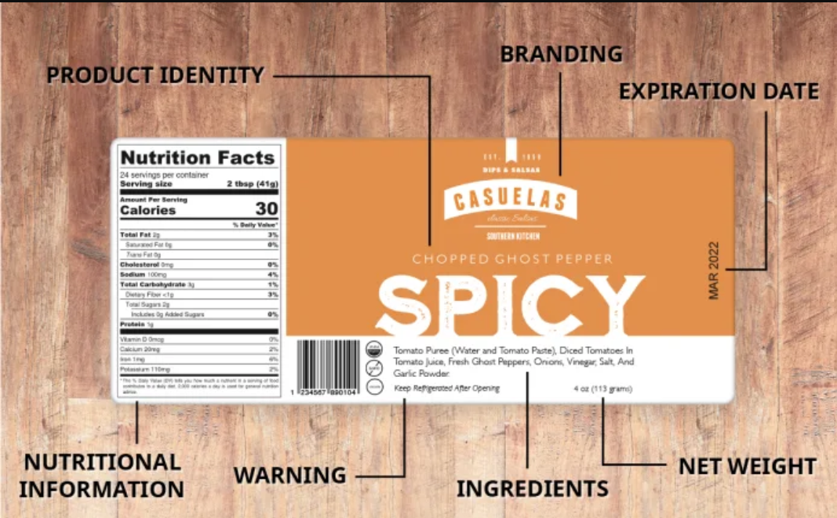

#2 - Now it is your turn. Pick one of your maple products (preferable a valued added product that has multiple ingredients). Design a label with the required components. Don’t have a company name or product yet? No worries, make one up and be creative.

#3 - Now take a moment to evaluate your work.
- Do you have all of the required food labeling elements?
- Is the net weight statement in the correct format on the bottom 1/3 of your label?
- Are the ingredients listed in order by weight not volume?
- Did you declare any allergens, if needed?

#4 - Next steps. Once you are at the label design phase of developing your syrup marketing or value-added product development, consider:
- Will the designing and printing be done in house?
- Do you have a printer you work with regularly? If so, provide them with the FDA labeling guidelines so they can design and print correctly.
- Don’t be afraid to shop around for label printing. Get quotes (they are not commitments) for several different quantities. Beware of additional fees you don’t know about up front---screen charges, shipping, etc.
- Proofs are designed for approval and modifications. Don’t be afraid to communicate errors and branding changes at this stage before you sign off on the proof and authorize printing. Have other members of your team look at the proof for errors---an incorrect phone number on the proof is difficult to change once the order is placed.
- Lastly, the proof stage is a great time to get labels reviewed for compliance in state branding programs or other programs that you use for marketing now and in the future.
#5 - Use the resources in this module or ask questions as you develop your product label. Don’t forget to complete the module evaluation.

